- Install Terraform on your PC.
Step 1:Goto official Terraform websiteDownload 386 (windows)
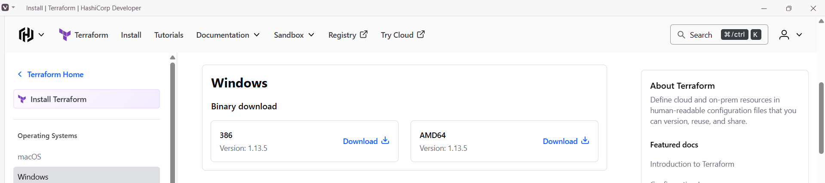
Step 2: Move the downloaded file to C drive and extract it.
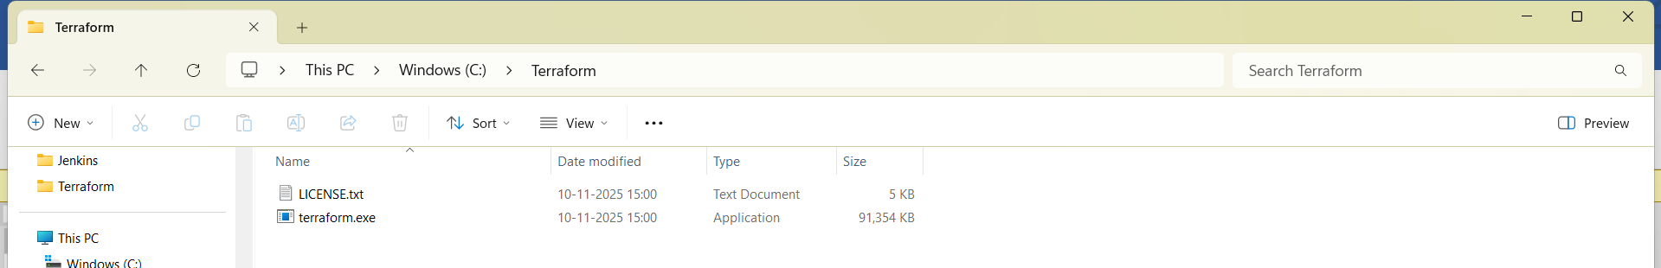
Step 3: open system environment variableEnvironment variablepathnewEnter detailsOK.
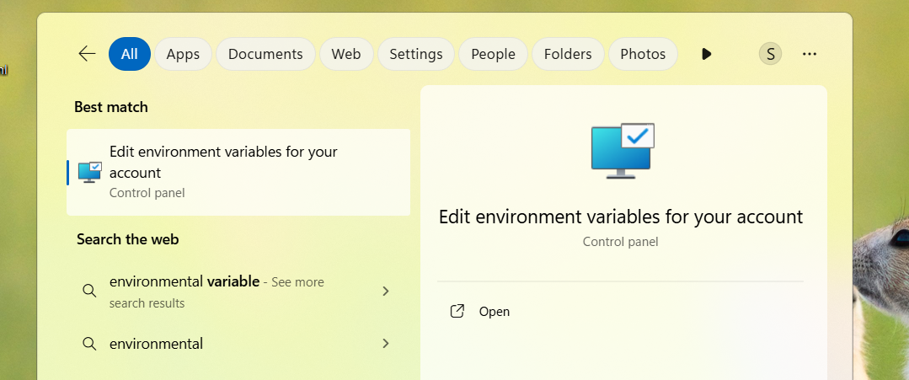
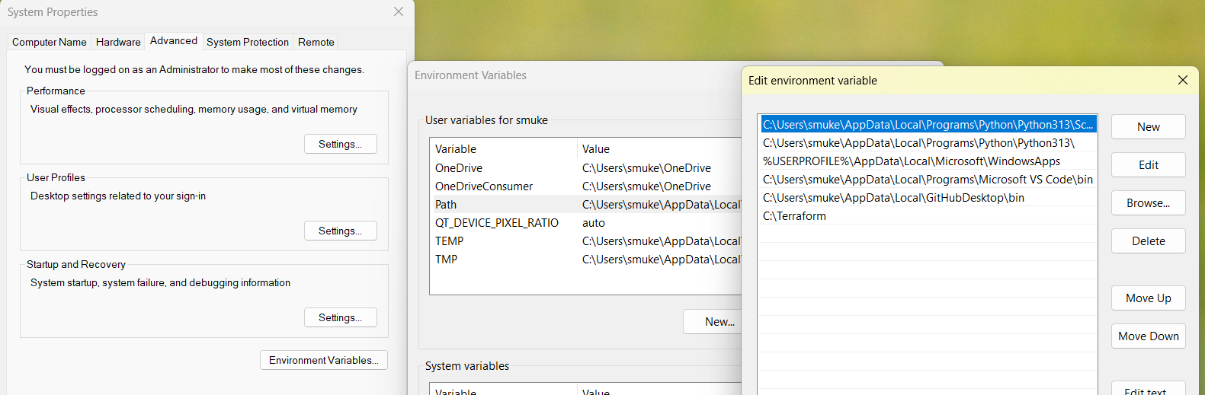
Step : open gitbash and enter terraform -v.
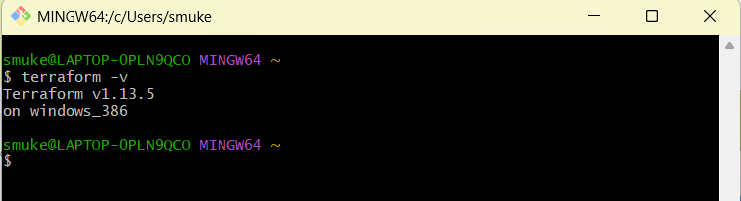
- Execute all the templates shown in video.
Step 1: Open VS codeextensionsearch Hashicorp TerraformInstall it.
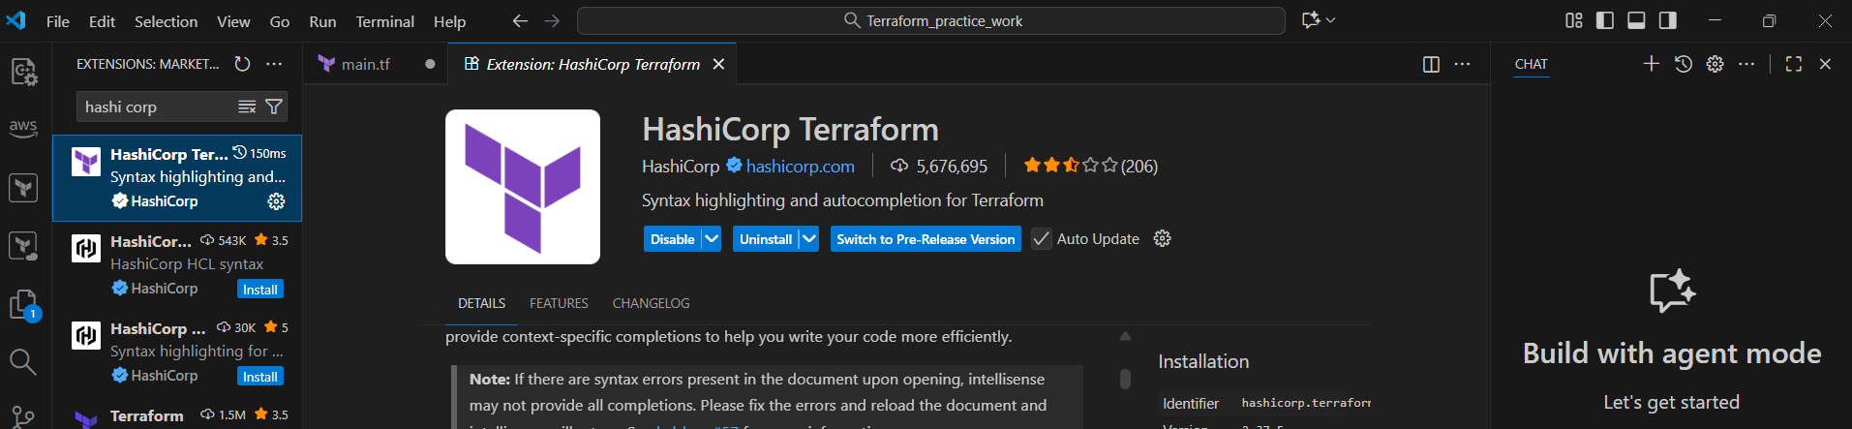
Step 2: Open fileopen folderselect folder.
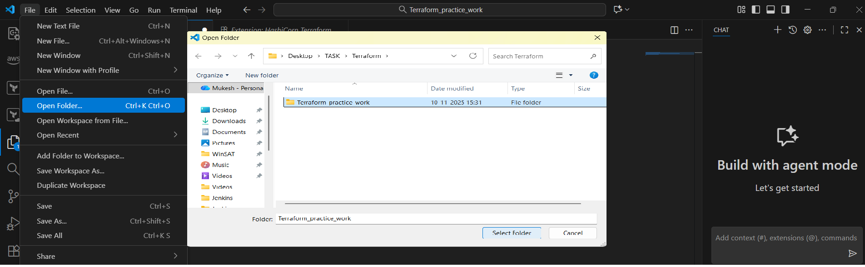
Step 3: Select filenew fileenter name with extension .tf(main.tf)enter.
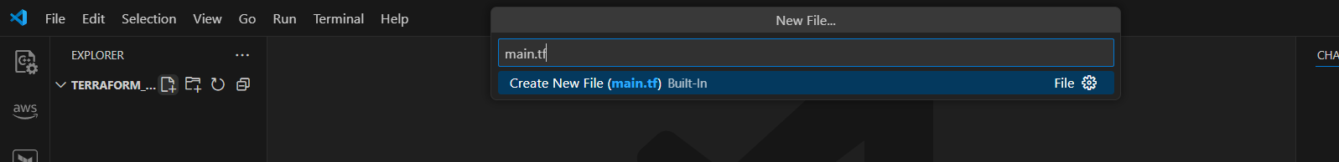
Step 4: Enter script in main.tf file and execute it in terminal using commands.
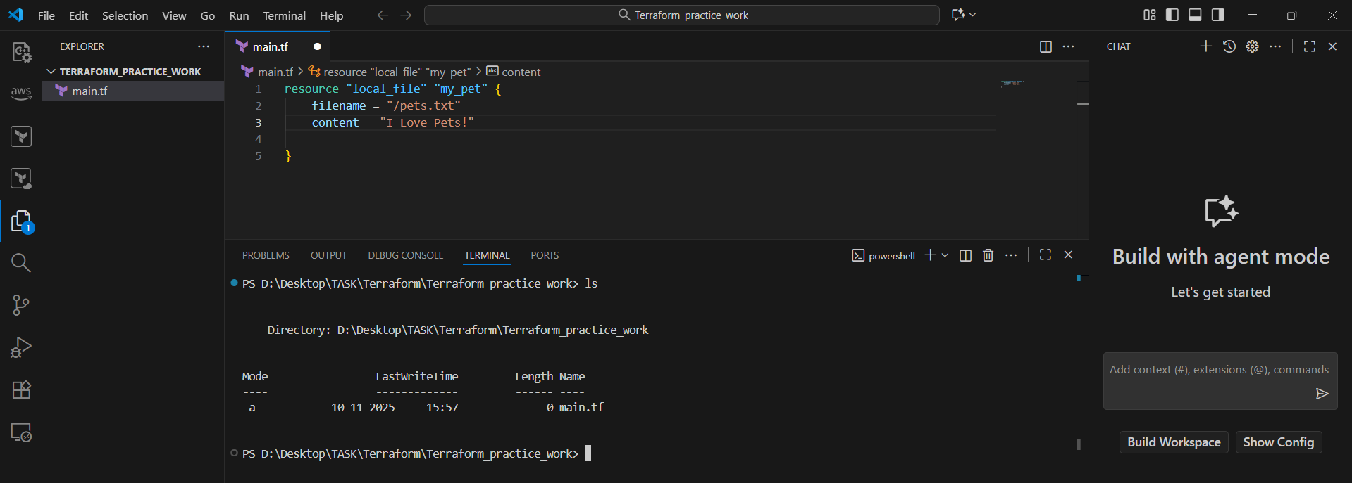

terraform init
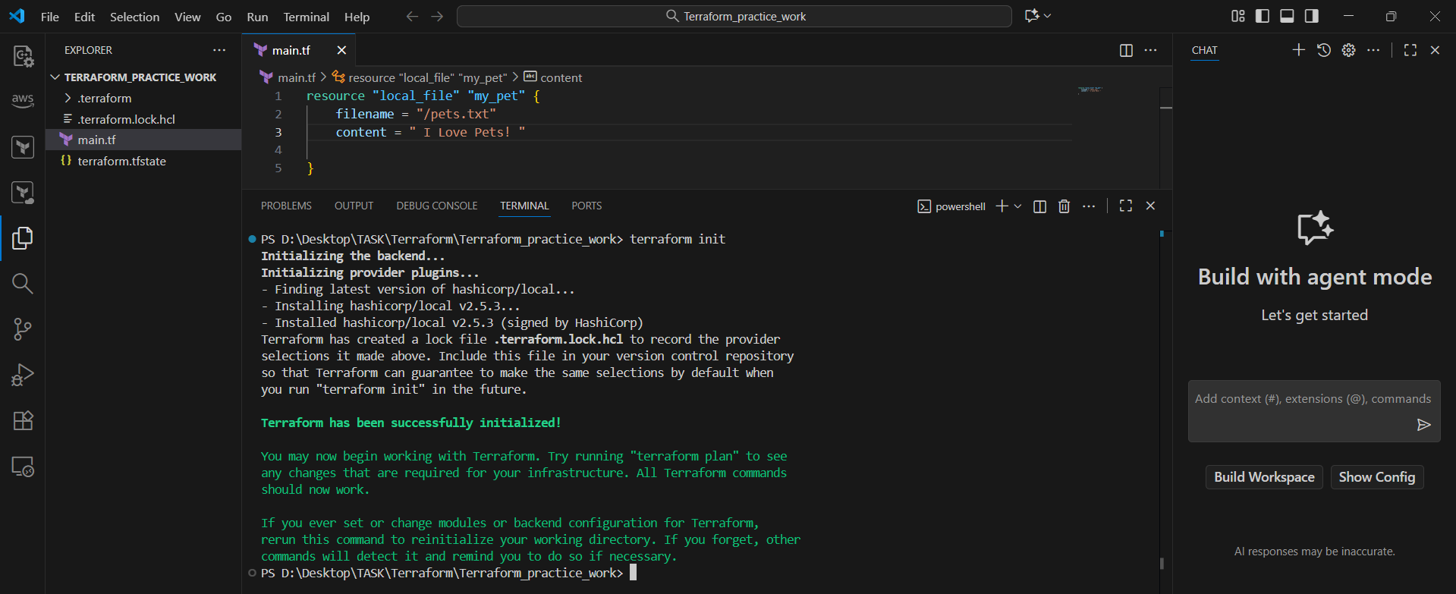
terraform plan
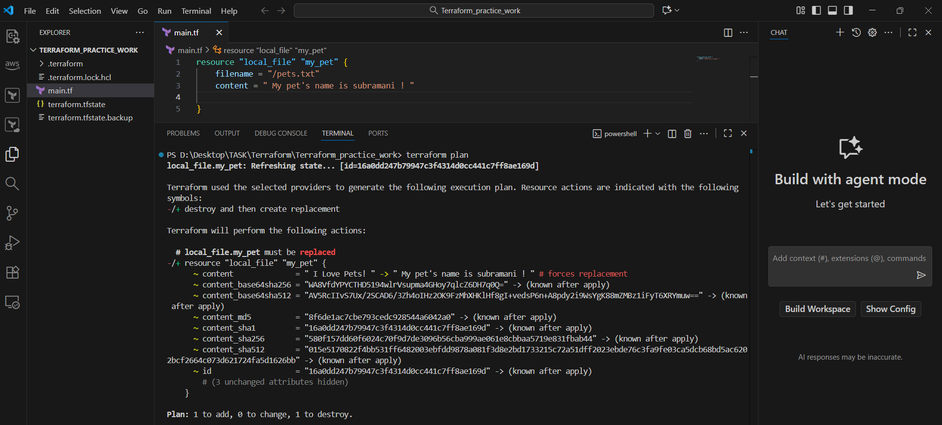
terraform apply
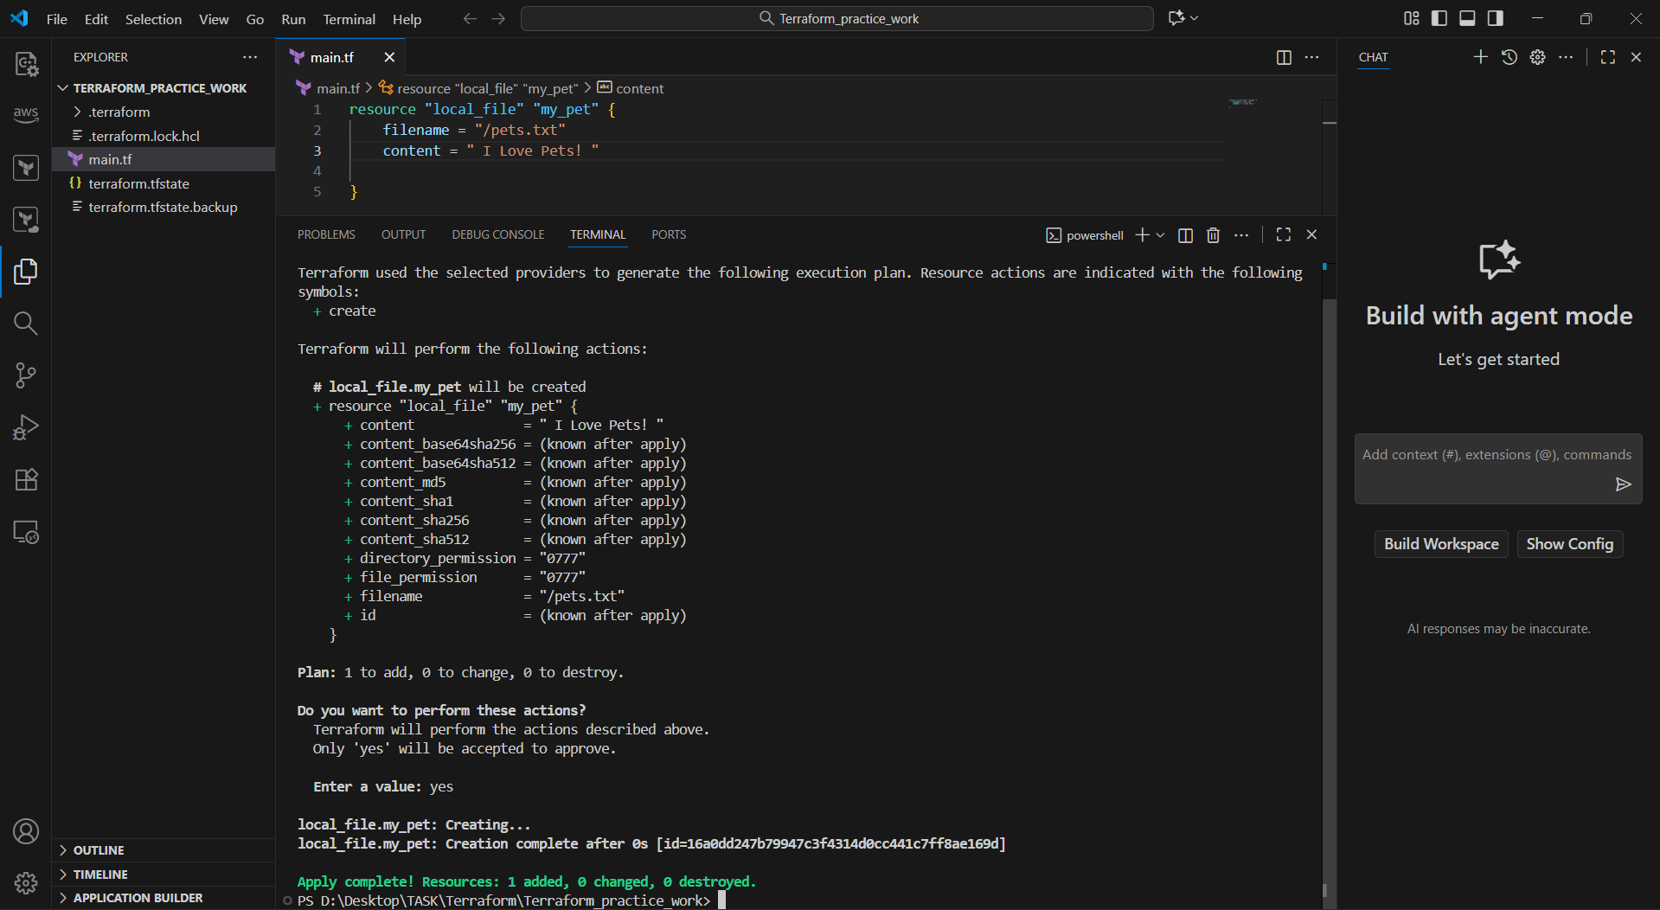

terraform destroy
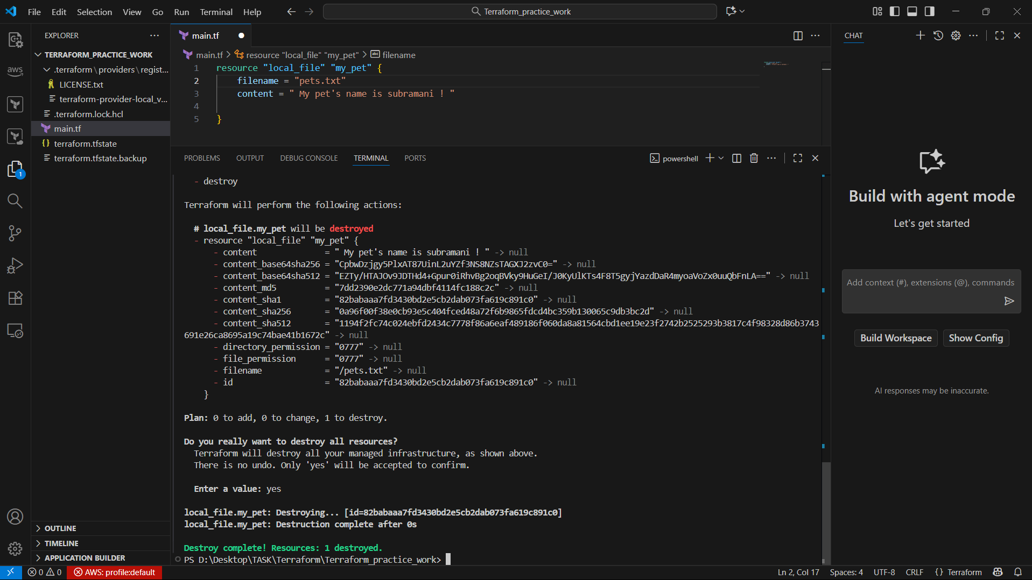
random_pet
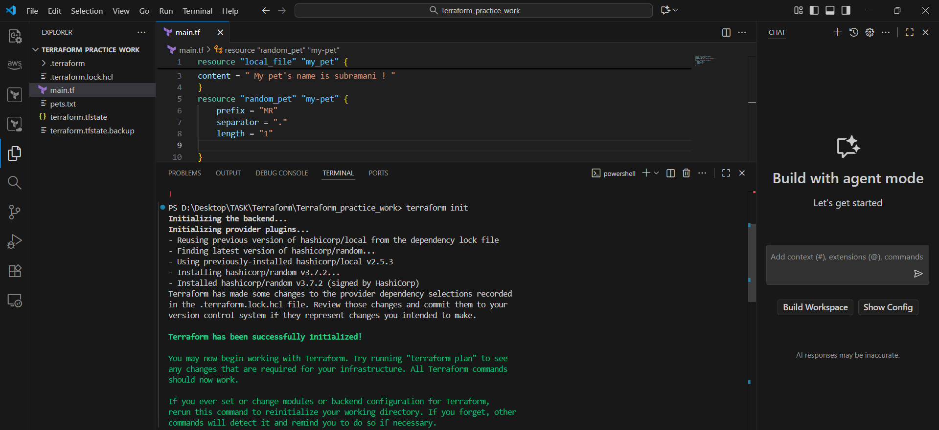
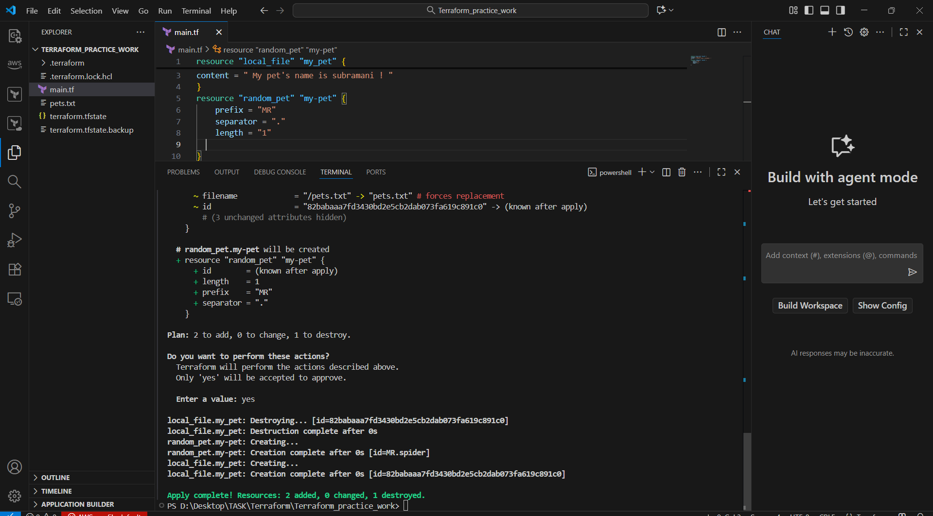
- Note down below points Terraform Init, Terraform Plan, Terraform Apply, Terraform Provider.

Terraform Init
The terraform init command is the first command executed when working with a new or existing Terraform configuration. It prepares the working directory for subsequent Terraform commands like terraform plan, terraform apply, and terraform destroy

Terraform Plan
Terraform plan is a core command in the Terraform workflow that creates an execution plan, allowing users to preview the changes Terraform will make to their infrastructure without actually applying those changes.

Terraform Apply
Terraform apply is a core command in the Terraform workflow responsible for executing the infrastructure changes defined in your configuration files. It is the step where your Infrastructure as Code (IaC) is transformed into tangible cloud resources.

Terraform Provider
A Terraform provider is a plugin that enables Terraform to manage resources by acting as an intermediary between Terraform and an external service or API. Each provider, such as the AWS or Azure provider, contains the logic to interact with a specific platform and perform actions like creating, updating, and deleting resources. This allows Terraform to manage infrastructure across various systems, like cloud providers, SaaS services, and other APIs, by simply configuring the appropriate provider.

- Integrate a sample Terraform template in jenkins.
Step 1:

